What’s New
OFS-USA Database Enhancements
. . . as of April 15, 2026
- Prior Election Snapshot
Created a process to more easily add a prior election snapshot. This capability is limited to a Super Admin. A Help Desk ticket can be opened for this to be done.

- New Fraternity Statuses
Added new fraternity statuses: Pending Deactivation, Fraternal Accompaniment.

- Fraternity Gathering Location
In the organization summary, display Fraternity Gathering Location instead of the mailing address.

- Improve Ability to Contact Us
Increased the ability to get help using “Contact Us” by displaying it on more App pages.

- Regional Data Quality Checks
Provide the capability to compute Regional data quality checks, which can be used by Admins to assess the completeness and correctness of data in their Region.

- Add Region Number to Fraternity Name Header
Instead of displaying only the fraternity number on the Fraternity Summary Page Header, precede it with a dash and the region number.

- Standardize Phone Format
Use the standard phone number format (999) 999-9999 for all phone numbers that were previously entered in a different format. We already have automatic formatting for all new phone numbers being entered.

- Add Member Status to Fraternity Roster
Adding member status to the Fraternity Roster will allow us to distinguish Active Professed vs. Active Excused Professed members for determining election voting eligibility and computing a quorum.

- Find Issues with Election Data
Allow the capability to perform a check on election data to find cases where data entry issues exist including any fraternity elections that are not fully updated, including those that do not have all their elected council members updated, or the Election Snapshot is missing. This can be executed from the Regional Summary Page.
RETURN TO ORG SUMMAR
- Local SA Contact Information needs to be Available to Fraternity Level Users
Allow users with limited permissions to see the contact information for the Spiritual Assistant in their fraternity. This can be done by using the Active Only Fraternity Roster.

. . . as of March 15, 2025
- Email Validation Status
The new email validation status field captures the results of our automated email validations. This field is displayed on the Regional Address List and on the Fraternity Roster. The Regional Address List now has a search criterion for Email Validation Status. You can select one or more statuses to display. 68% of our active OFS members (all profession statuses) have valid emails. 23% of the emails are blank. The Unverified email addresses are primarily visitors or aspirants who have not been included in bulk email campaigns.

Please note that the “Unsubscribe” category is the result of members unsubscribing to the bulk emails. We are required to exclude these emails from any bulk email campaign. This does not mean that you cannot use their email in personal correspondence.
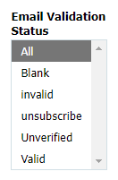
Validation Status | Active OFS | %
Unverified | 264 | 2.5%
Blank | 2,478 | 23.1%
Valid | 7,313 | 68.2%
Unsubscribe | 20 | 0.2%
invalid | 641 | 6.0%
 | 10,716

. . . as of January 26, 2025
- Initiated Dates for Newly forming Groups and Emerging Fraternities
Two new dates were added for tracking Newly Forming Groups and Emerging Fraternities – NFG Initiated Date and Emerging Fraternity Initiated Date. These dates can be entered or updated when a subsidiary is created or moves from one phase to the next.

- Emails Validated when entered or updated
We have implemented an automated process to validate emails as soon as they are entered or changed in the database. The user will be notified via email if an email if the email they entered is missing key elements, such as @ or period. The system them sends the email to our email validation software to determine if it is deliverable. If it is not, it will appear as an invalid email in the quality report.

The user will also be notified if they leave the email blank for a new or existing member. The reports also reflect blank emails as “invalid”. We recognize that there are members who do not have emails, and therefore a blank is not something that needs to be corrected. However, these are infrequent, so they will appear on the quality and other reports that indicate email status.
- Change in Permissions for Council Updates
There have been issues with updating council members when an election occurs. The Database Team determined that it is best to limit updates to Admins only at this point to make sure that the election update process in completed before other council changes are made. If you are a user, you will be able to view the council record, but not update it. You will need to involve your Regional Admin in making council changes.

. . . as of December 7, 2024
- New Membership Status Values for Candidates.
We have been informed by the NEC and CIOFS that the Temporary and Definitive Provisions in the General Constitutions for membership in the OFS (GC articles 56-60) do not apply to Candidates. We have revised the drop down values for Candidates to reflect valid values for those in candidacy. See Profession and Membership Status Primer for details. Below is a summary of Status Values.
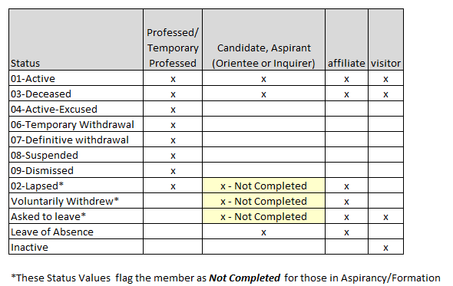

. . . as of October 28, 2024

- Fraternity Meeting Time and Place report added to the Regional Summary Page. This report gives you a list of all the active fraternities in the region along with their meeting time and location.

- TAU-USA Delivery method added to Regional Address List and Fraternity Roster. This field indicates whether the member is receiving the TAU-USA only by email, or by regular mail for the issue that is printed once a year.

- Fraternity Election & Visitation Dates report added on the Regional Summary Page. This report gives you a list of the fraternities with their current and estimated next dates for planning purposes. The Next Election date is calculated by the system as three years after the current election. The Next Pastoral and Fraternal Visitations date can be edited at the fraternity level.

. . . as of September 2, 2024

- Bad Email flag added to Regional Address List and Fraternity Roster. When you download these reports in csv format to create an email list for mailings, you can filter out the bad emails using Excel.
- User Permissions for organizations – available on Summary Pages. Check who has read or edit permissions to your organization. This report includes user category, which helps you understand why certain people have permissions to your organization.
- Add suffix to names in the Org Unit Positions display
- Implemented Brevo and Zero Bounce software tools for bulk email distribution from the database. This includes our ability to verify emails and provide feedback to administrators for corrections. These tools will be used to send emails to all active members (about 10,000) and track delivery. These bulk emails will only be sent with the approval of the NEC.
- Updated TAU-USA distribution process to reflect email distribution.

. . . as of May 25, 2024

- The Directory of Fraternity Councils report on the Regional Summary page now has a filter to select the fraternity councils for a specific group or district (or multiple groups and districts).

. . . as of March 29, 2024

- A Data Quality Report is now available on the National and Regional Summary Pages. See details about the report here: Data Quality Report User Documentation.

. . . as of March 7, 2024

- You can now access the National Directory from any Summary Page (Fraternity, Region, National and Province). No need to navigate to the National Summary Page to access it.

. . . as of February 8, 2024

- The National Directory is now live on the Database!
It is located on the National Summary Page, and requires either edit or read access to the National Organization, but can be shared as a pdf. Use caution when sharing, and emphasize that the data is only to be used internally to the OFS.
The information in the directory is fed from the database, but the report is not real time. It will be updated weekly.

. . . as of February 2, 2024

- New report for positions by persons/persons by position on the User Reports Page.

This report allows you to look up all the current positions (across organizations) for any person in the database. You can also search by position, which will give you a list of everyone in the database who currently holds that position.

- Added Province bonding to the fraternity list on the Region Summary Page.

- Revised User Reports page showing report links available directly from the page, a list of reports available on the Summary Pages (National, Regional, or Local Fraternity, Province), and a list of planned reports to be developed.

- Demographics report added to the National and Regional summary pages.

- Added link to the Regional Annual Report page on the Database login page.

